**Name – kushagra Aditya B atch no – 2**

**Sap id – 500121019**

**Devops lab experiment**

**Lab Exercise 1- Working with Git Revert**

**Lab Exercise: Git Revert**

This exercise will guide you through reverting changes in Git. The git revert command is used to create a new commit that undoes the changes introduced by a previous commit without modifying the history.

**Objective**

* Learn how to use git revert to undo changes from specific commits.
* Practice handling merge conflicts during a revert.

**Prerequisites**

1. Install Git on your system.
2. Set up a Git repository:

git init git-revert-lab

cd git-revert-lab

**Steps**

**1. Set Up the Repository**

1. Create a file:

echo "Line 1" > file.txt

1. Stage and commit the file:

git add file.txt

git commit -m "Initial commit: Add file.txt with Line 1"

1. Add more changes:

echo "Line 2" >> file.txt

git commit -am "Add Line 2 to file.txt"

1. Add another change:

echo "Line 3" >> file.txt

git commit -am "Add Line 3 to file.txt"

1. Verify the commit history:

git log --oneline

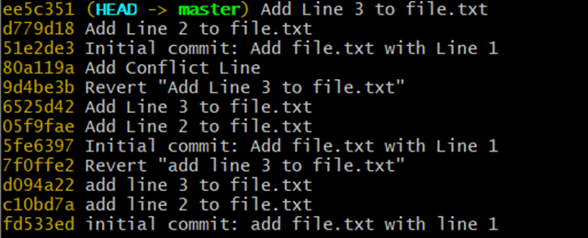Example output:

**2. Revert the Last Commit**

1. Revert the most recent commit:

git revert HEAD

1. Git will open a text editor for the commit message. Save and close the editor to complete the revert.
2. Verify the contents of file.txt:

cat file.txt

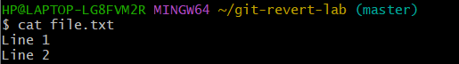Output:

1. Check the commit history:

git log --oneline

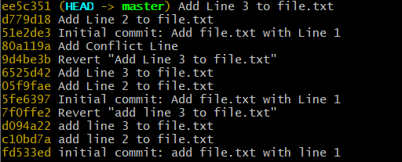Example output:

**3. Handle Merge Conflicts During Revert**

1. Modify file.txt:

Revert the second commit to trigger a conflict:

Git will indicate a conflict. Resolve it:

Open file.txt and remove conflict markers.

* + Keep the desired lines.

1. Stage the resolved file:

git add file.txt

1. Complete the revert:

git revert --continue